Troubleshooting Employee Self Service Emails to Class List

At the beginning of the semester, several faculty reported problems with emailing their students from the Faculty Self Service class list. Following is a review of the steps to follow in order to successfully email students from the Faculty and Advisor’s Menu.

Instructions | Screenshots
- Log into SOAR and select the Faculty and Advisor Services Tab | 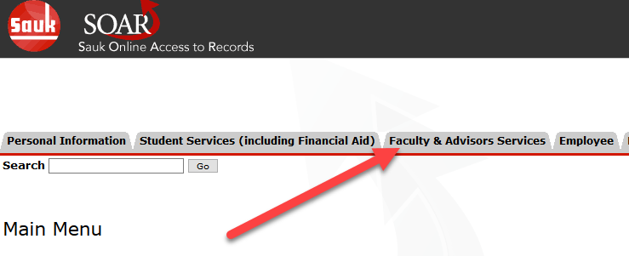
Select NEW Class List | 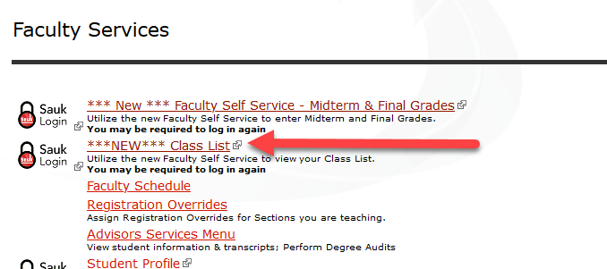
Select the current semester (1) and select a course (2). | 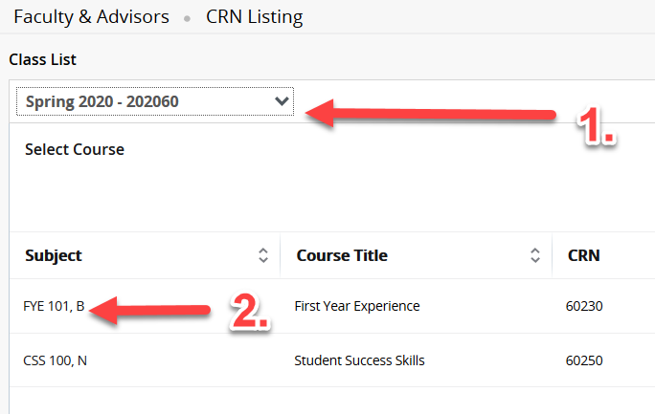
Select all students, or only those you wish to communicate with by checking the box adjacent to their names. | 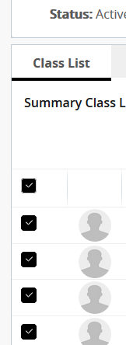
Select the mail icon. | 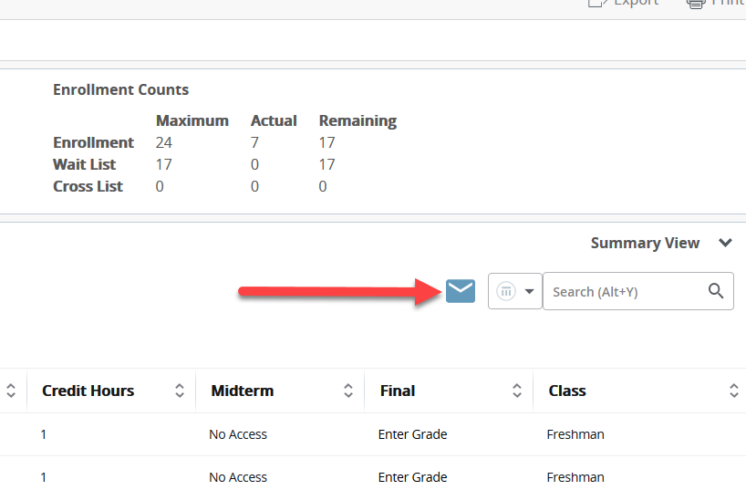

At this point, your email program should open on your computer and the email addresses of all selected students should autofill in the BCC address line of a new message.

If the email program does not open, the problem is most likely a setting on your computer browser that needs to be selected or updated. Please see the troubleshooting guide prepared below.

How to Have Gmail Handle Emails in Chrome

1. Open Gmail in Chrome and click the Protocol Handler icon.
Once your Ask protocol has been switched on for default handlers, open Gmail in a new tab and make sure you're signed in.

2. Allow Gmail to open all email links.
At the end of your address bar, you'll see a new icon that looks like two gray diamonds intertwined with each other. Click the icon.
*If the diamonds do not appear go to Alternative Steps*
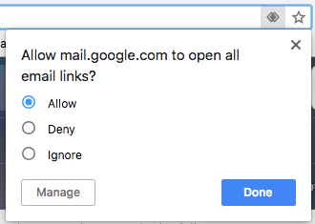
Click "Allow" in response to the question Chrome asks you, as shown above, and then hit Done. You'll officially have all "mailto:" links open in Gmail if they come from your Chrome browser.
*This might prompt the Windows “Default Apps”. If so, under Email click on it and change to Chrome.
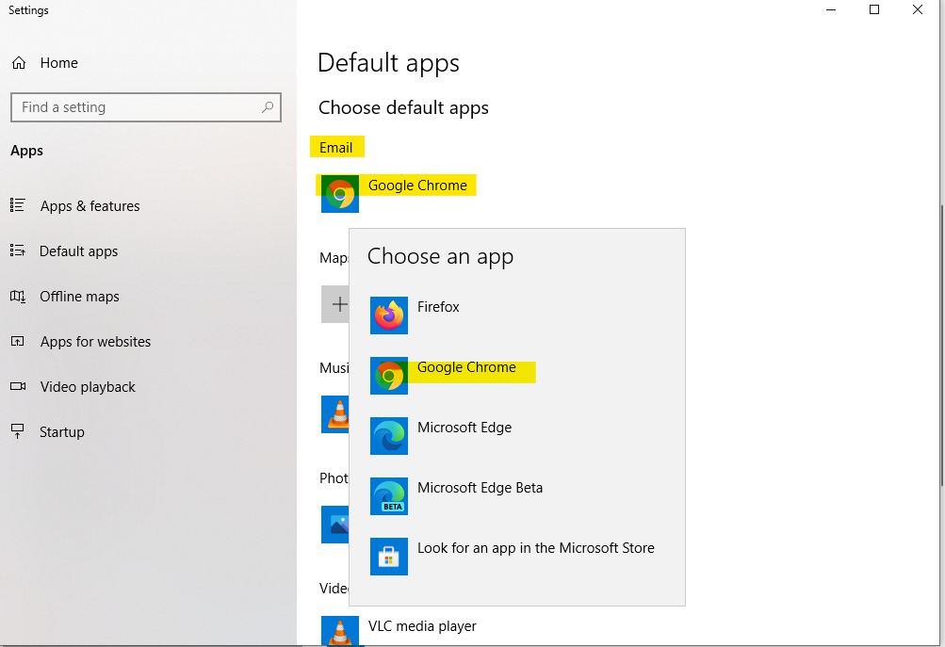

Alternative Steps
- Copy and paste this in the address bar chrome://settings/handlers
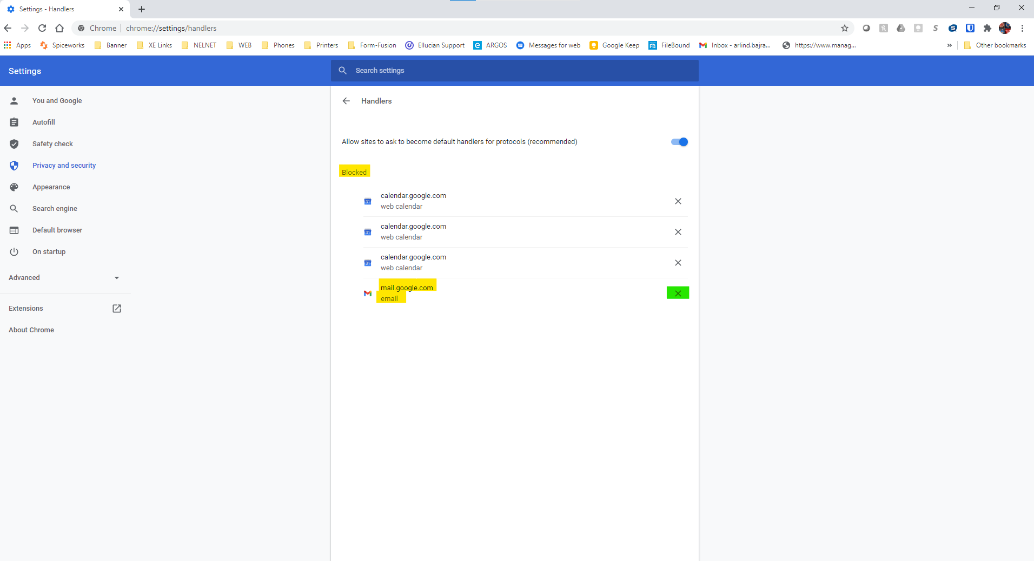
- You will see that Gmail is blocked. Remove it from the list by clicking the “X”. Go back to Step 1.

How to Have Gmail Handle Emails in Firefox

1. Open the Firefox menu on the upper-righthand corner of your browser.
Launch Firefox and look to the upper-righthand corner of your browser for an icon consisting of three horizontal lines on top of one another. Select the "Options" icon from this dropdown menu.

2. Find or search for "mailto" in the search bar.
Under the "Applications" settings of Firefox. Look for the "mailto" application in the lefthand column (if you don't see it listed, search for it in the "Applications" search bar above the list).
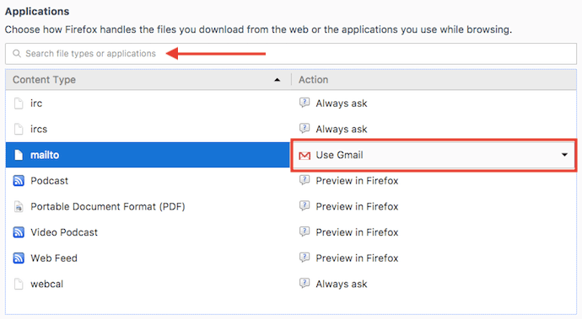
4. Next to "mailto," open the dropdown menu and select "Use Gmail."

In the righthand column of the applications list, click on the "mailto" row and select "Use Gmail." This will set Gmail as your default email client for all mailto links that come from Firefox. No need to save your settings Firefox does this automatically.
